ABBOTSFORD DISTRICT TEACHERS’ ASSOCIATION
2570 Cyril Street, Abbotsford, B.C. V2S 2G2
Telephone: 604-854-1946 Fax: 604-850-5100 www.adta.bc.ca

Professional Development Appeal Form
To be completed only if an Administrative Officer denies the Professional Development activity of an ADTA member

School/Site: ________________________________________________
Your NAME: _________________________________________________
Principal’s name: ___________________________________________

Timelines:
- Date of pd activity: ____ /____ /____ PD Day? yes☐ no☐
- Date when PD request was made: ____ /____ /____
- Date when PD request was denied: ____ /____ /____
Procedures:
- Did the adta members of your staff conduct a vote to determine a school focus for the PD day? yes☐ no☐

- If yes, was the result a positive vote of at least 50%+1? yes☐ no☐

- did you vote YES to participate in the event? yes☐ no☐

details:

- What is the title or focus of the pd activity/event that you will be attending? (where possible, identify the organization hosting the event)
______________________________________________________________________________________________________________________________________________________
- How does this activity/event support your professional growth:
______________________________________________________________________________________________________________________________________________________
- Reasons stated by the AO for denial:
______________________________________________________________________________________________________________________________________________________

Member’s Signature:____________________________ Date:____ /____ /____

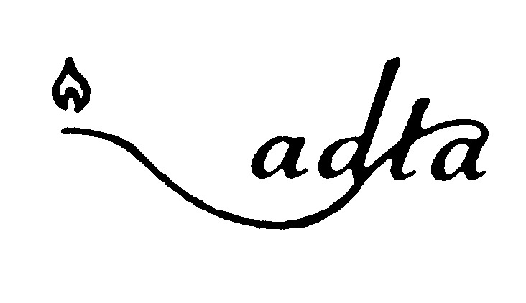
Please forward completed application to the ADTA office

