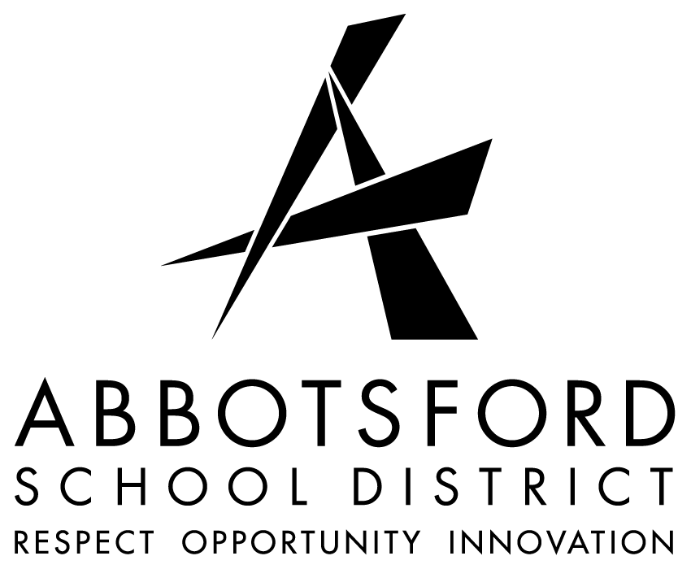
THE BOARD OF EDUCATION OF
SCHOOL DISTRICT NO. 34 (ABBOTSFORD)

POSTING: TEACHING POSITION

DATE: 04 SEPTEMBER 2018 TIME: 10:00 A.M.
PLEASE APPLY USING THE JOB SHOPPING WEB SYSTEM
EXTERNAL APPLICANTS APPLY TO: hr@abbyschools.ca

POSTING REFERENCE NO: T 19 TEL 168 TEM SCHOOL: KING TRADITIONAL ELEMENTARY

COMMENCEMENT DATE: 01 SEPTEMBER 2018 F.T.E.: .1 (SCHEDULE TBA)

CONTRACT: TEMPORARY (ASAP to 30 June 2019)

Position
TEACHER – ELEMENTARY
ENGLISH LANGUAGE LEARNER (ELL)

QUALIFICATIONS
- Elementary teacher training/experience from K-5
- TESL Certification is required
- ELL experience from K-5 is required
- Demonstrated commitment to ongoing professional learning and the implementation of high impact instructional strategies
- Elementary teacher training with a major or diploma in Special Education
- Experience working with at risk children and vulnerable families
- Experience and coursework focus in learning assistance preferred
- Appropriate coursework in developmental reading and learning disabilities
- Training and experience administering and interpreting KBIT2/KTEA II test assessments.
- Completion of the Cornerstone Workshops
- Carole Fullerton Math Workshop Training
- Coursework in Behaviour Management an asset
- Demonstrated ability to work as an effective member of school-based and integrated case management teams
- Knowledge/understanding of the Calm for Kids program
- Demonstrated ability to differentiate curriculum for a wide variety of learners
- Knowledge and demonstrated ability to develop diverse programs for children of different needs and abilities including, Autism, MID, LD, FASD, and other complex disorders
- Knowledge and ability in integrated case management
- Knowledge and understanding of multiple intelligences and learning styles.
- Knowledge and ability to network and collaborate with school and outside community agencies
- Demonstrated commitment to ongoing professional learning and the implementation of high impact instructional strategies
- Demonstrated ability to plan and organize curriculum, learning spaces, individualized programs
- Demonstrated ability to manage the changing dynamics of a classroom, or small groups of learners
- Demonstrated highly effective interpersonal and communication skills; must be able to communicate complex or sensitive issues in a positive manner
- Demonstrated ability to manage themselves, learners and others in a conflict situation
- Demonstrated ability to positively contribute to a team environment and a highly collaborative atmosphere
- Demonstrated ability to engage learners at all levels
- Demonstrated ability to use assessment as an effective tool for learning and charting progress
- Demonstrated ability to model safe, caring and inclusive behaviour and commitment to the success of all learners
- Experience with traditional school philosophy and values an asset
- Experience working with difficult to reach students and families or students and families in crisis
- Satisfactory teacher evaluation and/or final practicum report(s)
- Effective written and oral interpersonal skills
- A highly effective team member
- Eligible for B.C. Certification

POSTING CLOSES: DATE: 07 SEPTEMBER 2018 TIME: 10:00 A.M.

