ABBOTSFORD DISTRICT TEACHERS’ ASSOCIATION
2570 Cyril Street, Abbotsford, B.C. V2S 2G2
Telephone: 604-854-1946 Fax: 604-850-5100 www.adta.bc.ca

District Committee Application Form

Greetings,
Thank you for your interest in sitting on a District #34 committee as a representative for the ADTA. Please take a few moments to complete the following application, as it will be used in accordance with Article A.5 Committee Membership, in determining the selection of all committee members who are ultimately appointed by the ADTA Executive.

Committee name:

Your Name: ____________________________________________________

Your School/Worksite: ________________________________________

List any district committees that you are currently sitting on.
- ____________________________________
- ____________________________________
- ____________________________________

Why do you wish to sit on this district committee?
_______________________________________________________________________________
_______________________________________________________________________________
_______________________________________________________________________________
_______________________________________________________________________________
_______________________________________________________________________________
_______________________________________________________________________________
_______________________________________________________________________________
_______________________________________________________________________________

What skills or expertise would you bring to this position?
_______________________________________________________________________________
_______________________________________________________________________________
_______________________________________________________________________________
_______________________________________________________________________________
_______________________________________________________________________________
_______________________________________________________________________________
_______________________________________________________________________________
_______________________________________________________________________________

*Please note that as a member of the committee, you will be representing the ADTA, and may be requested to report to the ADTA Executive on the progress of the committee’s work.

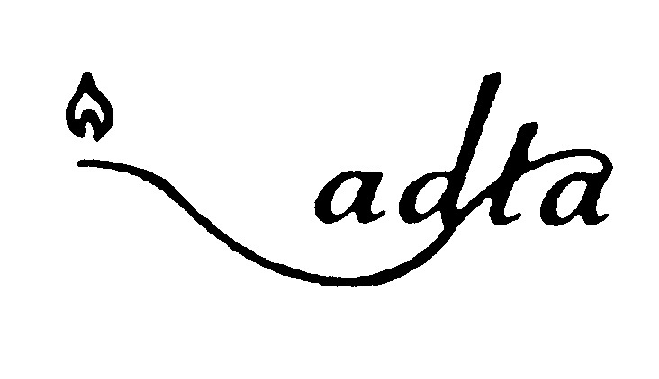
Please forward completed application to the ADTA office

